

# Dayananda Sagar College of Engineering

Shavige Malleshwara Hills, Kumaraswamy Layout, Bangalore -5600078 (An Autonomous Institute Affiliated to VTU Approved by AICTE & ISO

9001:2015 Certified Accredited by National Assessment & Accreditation Council (NAAC) with ‘A’ Grade)

**ONE-BLOOD**

A Mini Project Report on Web Technology

*Submitted in partial fulfilment of the requirements for the Award of MCA degree.*

**Master of Computer Applications Submitted to**

**Dayananda Sagar College of Engineering**

**Supervised By DR. CHANDRIKA. M**

**Submitted By**

**A.S. SHRIDHAR KAKADE (1DS21MC001)**

**C.S. ARVIND RITHVIK (1DS21MC028)**

CERTIFICATE

I hereby certify that the work which is being presented in the MCA, mini project report entitled ‘**ONE – BLOOD’,** in partial fulfilment of the requirements for the award of the MCA and submitted to the **Department of MCA, Dayananda Sagar College of Engineering, Bangalore** is an authentic record of my own work carried out during the period of Aug-2021 (II Semester) under the supervision of **Dr. Chandrika M, Department of MCA.**

The matter presented in this project report has not submitted by me for the award of any other degree elsewhere.

**Signature of Student(s)**

This is to certify that the above statement made by the students is correct to the best of my knowledge

##### Signature of Supervisor Signature of HOD

**Dr. Chandrika M Dr. Samitha Khaiyum**

## ACKNOWLEDGEMENT

I would like to place on my record my deep sense of gratitude to

**Dr. Samitha Khaiyum**, HOD Department of MCA, Dayananda Sagar College of Engineering Bangalore, India for the generous guidance, help and useful suggestions.

I express my sincere gratitude to **Dr. Chandrika M,** Department of MCA, Dayananda Sagar College of Engineering, Bangalore, India for her stimulating guidance, continuous encouragement, and supervision throughout the course of present work.

**Signature of Student(s)**

**Table of Contents**

Acknowledgement 3

List of Tables 4

1. Introduction 5
   1. Project Modules 5
2. Implementation 7
   1. Home Page 7
   2. Blood Request 22
   3. Blood Donor 25
   4. Admin Page 28
   5. CSS 30
   6. JavaScript 35
3. Tools and technologies 44
4. Conclusion 45
   1. Limitations and Future Enhancements 45
5. Bibliography 46

**Introduction**

A blood donation is a process whereby a person voluntarily has blood drawn to be used for future transfusions when in need at hospitals for treatment procedures that require them. Donation may be of whole blood (blood drawn directly from the body) or of specific components of the blood; such as red blood cells, white blood cells, plasma, and platelets. Blood banks often participate in the process of collecting blood and other procedures such as managing stocks, approving blood requests, and updating donation information.

BLOOD-ONE is a software application to maintain day today transactions in a blood bank. This software help to register all the donors, Blood collection details, blood issued details etc.d.

**Project modules:**

The following are the modules for the OneBlood

### Blood Request:

This entity is used to store the information of Requestor who are Requesting for blood.Once the registration process done admin verifies the details and provides the available blood details The attributes of this entity is listed below

* Name
* Age
* Phone number
* Blood Group
* Gender
* Email Id

### Blood Donation:

The donor connects with the customer for blood donation. Here the customer uses the blood request form in order to find for a potential donor.

Here, this module is used to store the information of Donor who are Registering for blood donation. Once the registration process done admin verifies the details and can contact them to visit and donate the blood.

The attributes of this entity is listed below:

* Name
* Email Id
* Contact Number
* Blood group
* Height
* Weight
* Gender

### Admin Module:

Here the admin manages and maintains the blood request and blood donation and all the sub modules.

Admin can see the List of Donor, can add Donor, see the list Approve Blood request. The sub modules under this are:

##### Add Donor:

Admin can add the donors to his main module by getting the donor list in “See Donor” section.

##### List of Donor:

Here, Admin can see the list of donors who has registered through this website.

##### Manage Stock:

Here, Admin manages the stocks of blood. If there is any shortage of any one kind of blood then, admin will raise the stock volume

##### Blood Request:

In this section, Admin watches the request forms sent by the request makers.

##### Approving of blood request:

Here, Admin can approve or rejects the blood requests that has raised by request makers.

# CODE IMPLIMENTATION

### Home Page :

<!DOCTYPE html>

<html lang="en">

<head>

<meta charset="UTF-8">

<meta name="viewport" content="width=device-width, initial-scale=1.0">

<meta http-equiv="X-UA-Compatible" content="ie=edge">

<!-- Font Awesome -->

<link rel="stylesheet" href="https://use.fontawesome.com/releases/v5.8.2/css/all.css">

<!-- Bootstrap core CSS -->

<link href="https://cdnjs.cloudflare.com/ajax/libs/twitter-bootstrap/4.3.1/css/bootstrap.min.css" rel="stylesheet">

<!-- Material Design Bootstrap -->

<link href="https://cdnjs.cloudflare.com/ajax/libs/mdbootstrap/4.10.1/css/mdb.min.css" rel="stylesheet"> <!-- JQuery -->

<script type="text/javascript" src="https://cdnjs.cloudflare.com/ajax/libs/jquery/3.4.1/jquery.min.js"></script>

<!-- Bootstrap tooltips -->

<script type="text/javascript" src="https://cdnjs.cloudflare.com/ajax/libs/popper.js/1.14.4/umd/popper.min.js"></script>

<!-- Bootstrap core JavaScript --> <script type="text/javascript"

src="https://cdnjs.cloudflare.com/ajax/libs/twitterbootstrap/4.3.1/js/bootstrap.min.js"></script>

<!-- MDB core JavaScript --> <script type="text/javascript" src="https://cdnjs.cloudflare.com/ajax/libs/mdbootstrap/4.10.1/js/mdb.min.js"></script>

<!-- favicon -->

<link rel="shortcut icon" type="image/png" href="favicon.ico" />

<!-- stylesheet -->

<link rel="stylesheet" href="css/style-min.css">

<title>OneBlood</title>

</head>

<body>

<!--Navbar -->

<nav class="mb-1 navbar navbar-expand-lg navbar-dark danger-color">

<a class="navbar-brand" href="#">OneBlood</a>

<button class="navbar-toggler" type="button" data-toggle="collapse" datatarget="#navbarSupportedContent-333" aria-controls="navbarSupportedContent-333" aria-expanded="false" aria-label="Toggle navigation">

<span class="navbar-toggler-icon"></span>

</button>

<div class="collapse navbar-collapse" id="navbarSupportedContent-333">

<ul class="navbar-nav mr-auto">

<li class="nav-item active">

<a class="nav-link" href="#">Home

<span class="sr-only">(current)</span>

</a>

</li>

<li class="nav-item">

<a class="nav-link" a href="#container2">Campaign</a>

</li>

<li class="nav-item">

<a class="nav-link" a href="#pages">Pages</a>

</li>

<li class="nav-item">

<a class="nav-link" a href="#blog">Blog</a>

</li>

<li class="nav-item">

<a class="nav-link" a href="#Contact">Contact</a>

</li>

<li class="nav-item">

<a class="nav-link" a href="#About">About Us</a>

</li>

</ul>

<ul class="navbar-nav ml-auto nav-flex-icons">

<li class="nav-item">

<a class="nav-link waves-effect waves-light">

<i class="fab fa-twitter"></i>

</a>

</li>

<li class="nav-item">

<a class="nav-link waves-effect waves-light">

<i class="fab fa-google-plus-g"></i>

</a>

</li>

<li class="nav-item dropdown">

<a class="nav-link dropdown-toggle" id="navbarDropdownMenuLink-333" datatoggle="dropdown"

aria-haspopup="true" aria-expanded="false">

<i class="fas fa-user"></i>

</a>

<div class="dropdown-menu dropdown-menu-right dropdown-default" aria-labelledby="navbarDropdownMenuLink-333"> <a class="dropdown-item" href="#">Dropdown menu 1</a>

<a class="dropdown-item" href="#">Dropdown menu 2</a>

<a class="dropdown-item" href="#">Dropdown menu 3</a>

</div>

</li>

</ul>

</div>

</nav>

<!--/.Navbar -->

<!-- Jumbotron -->

<div class="card card-image img-fluid"

style="background-image: url('images/main.jpg'); background-size: cover;">

<div class="text-white text-center rgba-stylish-strong py-5 px-4">

<div class="py-5">

<!-- Content -->

<h4 class="card-title h4 my-4 py-2">DONATE BLOOD, SAVE LIFE!</h4>

<h1 class="mb-4 pb-2 px-md-5 mx-md-5">DONATE YOUR BLOOD AND INSPIRE<br>OTHERS TO DONATE.</h1>

<a class="btn btn-danger">JOIN WITH US <i class="fas fa-arrow-right"></i></a>

</div>

</div>

</div>

<!-- Jumbotron -->

<div class="container-fluid" id="container">

<div class="card text-center" id="prompt">

<div class="card-body">

<h4 class="card-title"><strong>WE ARE HERE FOR HELPING PEOPLE</strong></h4>

<p class="card-text">You can give blood at any of our blood donation venues. We have several donor

centers

and visit other vanues on various occassions</p>

<a href="#!" class="btn btn-danger">REQUEST BLOOD</a>

</div>

</div>

</div>

<div class="container-fluid" id="container2">

<!-- jumbotron -->

<div class="jumbotron jumbotron-fluid text-center">

<div class="container">

<h3 class="display-4">DONATION PROCESS</h3>

<hr class="dots">

<p class="lead">The donation process from the time you arrive at center until the time you leave</p>

</div>

</div>

<!-- jumbotron -->

<div class="container-fluid mb-5">

<!-- Card deck -->

<div class="card-deck">

<!-- Card -->

<div class="card mb-3">

<!--Card image-->

<div class="view overlay">

<img class="card-img-top" src="images/registration.jpg" alt="Card image cap">

<a href="#!">

<div class="mask rgba-white-slight"></div>

</a>

</div>

<!--Card content-->

<div class="card-body">

contatins all

</div>

<!--Title-->

<h4 class="card-title">REGISTRATION</h4>

<!--Text-->

<p class="card-text">You need to complete a very simple registration form which required contact information to enter in the donation process.</p>

</div>

<!-- Card -->

<!-- Card -->

<div class="card mb-3">

<!--Card image-->

<div class="view overlay">

<img class="card-img-top" src="images/bloodcheck.jpg" alt="Card image cap">

<a href="#!">

<div class="mask rgba-white-slight"></div>

</a>

</div>

<!--Card content-->

<div class="card-body">

test to ensure

</div>

<!--Title-->

<h4 class="card-title">SCREENING</h4>

<!--Text-->

<p class="card-text">A drop of blood from your finger will be taken for a simple that your blood levels are proper enough for donation.</p>

</div>

<!-- Card -->

<!-- Card -->

<div class="card mb-3">

<!--Card image-->

<div class="view overlay">

<img class="card-img-top" src="images/donation.jpg" alt="Card image cap">

<a href="#!">

<div class="mask rgba-white-slight"></div>

</a>

</div>

<!--Card content-->

<div class="card-body">

to a donor

</div>

<!--Title-->

<h4 class="card-title">DONATION</h4>

<!--Text-->

<p class="card-text">After passing screening test successfully you will be directed bed for donation. It will take only 6-10 minutes.</p>

</div>

<!-- Card -->

<!-- Card -->

<div class="card mb-3">

<!--Card image-->

<div class="view overlay">

<img class="card-img-top" src="images/Refreshment.jpg" alt="Card image cap">

<a href="#!">

<div class="mask rgba-white-slight"></div>

</a>

</div>

<!--Card content-->

<div class="card-body">

<!--Title-->

<h4 class="card-title">REFRESHMENT</h4>

<!--Text-->

<p class="card-text">you can also stay in the sitting room until you feel strong enough to leave

the center. You will receive refreshments in the donation zone</p>

</div>

</div>

<!-- Card -->

</div>

<!-- Card deck -->

</div>

</div>

<div class="container-fluid mb-5" id="quote">

<div class="row">

<div class="col-sm-6 col-md-6">

<!-- <img src="images/quote2.jpg" alt="" srcset="" class="img-fluid"> -->

<section class="p-1">

<div class="streak grey lighten-3" id="pages">

<div class="flex-center">

<ul class="mb-0 list-unstyled">

<li>

<h2 class="h2-responsive"><i class="fas fa-quote-left" ariahidden="true"></i> A

smiles.

</li>

single pint can save three lives. A single gesture can create a million

<i class="fas fa-quote-right" aria-hidden="true"></i></h2>

<li class="mb-0">

<h5 class="text-center font-italic mb-0">~ American Red Cross</h5>

</li>

</ul>

</div>

</div>

</section>

<section class="p-1">

<div class="streak lighten-3">

<div class="flex-center">

<ul class="mb-0 list-unstyled">

<li>

<h2 class="h2-responsive"><i class="fas fa-quote-left" ariahidden="true"></i> Bring

a life back to power. Make blood donation your responsibility <i class="fas fa-quote-right" aria-hidden="true"></i></h2>

</li>

<li class="mb-0">

<h5 class="text-center font-italic mb-0">~ American Red Cross</h5>

</li>

</ul>

</div>

</div>

</section>

</div>

</div>

</div>

<!-- jumbotron -->

<section id="instructions" class="care-section grid">

<h2>Pre donation instructions</h2>

<div class="care-section content">

<div>

<img src="images/sleep.png" alt="sleep photo" />

<p>Get enough sleep on the night of the donation.</p>

</div>

<div>

<img src="images/eat.png" alt="Eat photo" />

<p>Eat a balanced meal two hours before donating.</p>

</div>

<div>

<img src="images/no-drink.png" alt="no drink photo" />

<span class="icon icon--error"></span>

<p>You should not drink liquids with caffeine.</p>

</div>

<div>

<img src="images/Drink.png" alt="drink photo" />

<p>You should drink more fluids than usual.</p>

</div>

</div>

</section>

<!-- End Pre donation -->

<!-- Start Donation instructions -->

<section class="instructions grid ">

<div class="instructions-header">

<h2>Donation instructions</h2>

<span class="icon"></span>

</div>

<div class="instructions-main">

<div class="instructions-main desc">

<div class="left">

<img src="images/reception.png" alt="image some instructions" />

</div>

<div class="right">

<h3>Go to the reception</h3>

<p>The donor starts their journey by contacting the registry.</p>

</div>

</div>

<div class="instructions-main desc">

<div class="left">

<img src="images/blood sample.png" alt="image some instructions" />

</div>

<div class="right">

<h3>Take blood sample</h3>

<p>

Take a blood sample and test to determine whether or not to donate. </p>

</div>

</div>

<div class="instructions-main desc">

<div class="left">

<img

src="images/Doctor's permit.png" alt="image some instructions"

/>

</div>

<div class="right">

<h3>Doctor's permit</h3>

<p>The doctor makes a decision about accepting a blood donation.</p>

</div>

</div>

<div class="instructions-main desc">

<div class="left">

<img src="image/eat.png" alt="image some instructions" />

</div>

<div class="right">

<h3>Food</h3>

<p>

Before donating it is necessary to eat a meal, do not donate blood on an empty stomach.

</p>

</div>

</div>

<div class="instructions-main desc">

<div class="left">

<img src="images/donation room.png" alt="image some instructions" /> </div>

<div class="right">

<h3>Blood donation</h3>

<p>

The donation is made in the donation room.

</p>

</div>

</div>

<div class="instructions-main desc">

<div class="left">

<img

<p>

src="images/Donors certificate.png" alt="image some instructions"

/>

</div>

<div class="right">

<h3>Donor's certificate</h3>

After donating, the donor's certificate will be issued.

</p>

</div>

</div>

</div>

</section>

<!-- End Donation instructions -->

<!-- start Post donation -->

<section id="instructions" class="care-section grid">

<h2>Post donation instructions</h2>

<div class="care-section content">

<div>

<img src="images/Drink.png" alt="drink photo" />

<p>You should drink more fluids than usual.</p>

</div>

<div>

<img src="images/break.png" alt="break photo" />

<p>After donating, take a break and snack.</p>

</div>

<div>

<img src="images/Leave.png" alt="leave photo" />

<p>After 10-15 minutes you can leave the place.</p>

</div>

<div>

<img src="images/gym.png" alt="gym photo" />

<span class="icon icon--error"></span>

<p>Avoid heavy physical activity for 5 hours.</p>

</div>

</div>

</section>

<div class="jumbotron jumbotron-fluid text-center" id="blog">

<div class="container">

<h3 class="display-4">OUR VOLUNTEERS</h3>

<hr class="dots">

<p class="lead">The volunteers who give their talent and time to fulfill the mission.</p>

</div>

</div>

<!-- jumbotron -->

<div class="container-fluid mb-5" id="container2">

<div class="container">

<!-- Card deck -->

<div class="card-deck">

<!-- Card Narrower -->

<div class="card card-cascade narrower mb-6">

<!-- Card image -->

<div class="view view-cascade overlay">

<img class="card-img-top" src="https://mdbootstrap.com/img/Photos/Others/men.jpg"

alt="Card image cap">

<a>

<div class="mask rgba-white-slight"></div>

</a>

</div>

<!-- Card content -->

<div class="card-body card-body-cascade text-center">

<!-- Title -->

<h4 class="card-title"><strong>Arvind Rithvik</strong></h4>

<!-- Subtitle -->

<h6 class="font-weight-bold indigo-text py-2">Student</h6>

<!-- Text -->

<p class="card-text">

Lorem ipsum dolor sit amet, consectetur adipisicing elit. Voluptatibus, ex, recusandae. Facere modi sunt, quodquibusdam.

</p>

<!-- Facebook -->

<a type="button" class="btn-floating btn-small btn-fb"><i class="fab fa- facebookf"></i></a>

<!-- Twitter -->

<a type="button" class="btn-floating btn-small btn-tw"><i class="fab fatwitter"></i></a>

<!-- Google + -->

<a type="button" class="btn-floating btn-small btn-instagram"><i class="fab fa-instagram"></i></a> </div>

</div>

<!-- Card Narrower -->

<!-- Card Narrower -->

<div class="card card-cascade narrower mb-6">

<!-- Card image -->

<div class="view view-cascade overlay">

<img class="card-img-top" src="https://mdbootstrap.com/img/Photos/Others/photo6.jpg"

alt="Card image cap">

<a>

<div class="mask rgba-white-slight"></div>

</a>

</div>

<!-- Card content -->

<div class="card-body card-body-cascade text-center">

<!-- Title -->

<h4 class="card-title"><strong>Shridhar Kakade</strong></h4>

<!-- Subtitle -->

<h6 class="font-weight-bold indigo-text py-2">Student</h6>

<!-- Text -->

<p class="card-text">Lorem ipsum dolor sit amet, consectetur adipisicing elit.

Voluptatibus, ex, recusandae. Facere modi sunt, quod quibusdam.

</p>

<!-- Facebook -->

<a type="button" class="btn-floating btn-small btn-fb"><i class="fab fa- facebookf"></i></a>

<!-- Twitter -->

<a type="button" class="btn-floating btn-small btn-tw"><i class="fab fatwitter"></i></a>

<!-- Google + -->

<a type="button" class="btn-floating btn-small btn-instagram"><i class="fab fa-instagram"></i></a>

</div>

</div>

<!-- Card Narrower -->

</div>

<!-- Card deck -->

</div>

</div>

<div class="container-fluid" id="container2">

<!-- Jumbotron -->

<div class="jumbotron text-center grey darken-3 white-text mx-2 mb-5">

<!-- Title -->

<h2 class="card-title h2">JOIN WITH US AND SAVE LIFE</h2>

<div class="pt-2">

<button type="button" class="btn btn-danger btn-rounded">BECOME A VOLUNTEER</button>

</div>

<hr class="my-4 rgba-white-light">

</div>

<!-- Jumbotron -->

</div>

<!-- Footer -->

<footer class="page-footer font-small danger-color pt-4">

<!-- Footer Links -->

<div class="container-fluid text-center text-md-left" id="About">

<!-- Grid row -->

<div class="row">

<!-- Grid column -->

<div class="col-md-6 mt-md-0 mt-3" id="About">

<!-- Content -->

<h5 class="text-uppercase">Lets make all OneBlood-ed</h5>

<p>OneBlood is a web based blood Donation platform which connects thousands of blood donors in three

simple steps. Bonded ensures hassle free blood donation and privacy of a blood donor. A blood

donor can select any specific date and location to donate blood and find a suitable

person who

needs blood. </p>

</div>

<!-- Grid column -->

<hr class="clearfix w-100 d-md-none pb-3">

<!-- Grid column -->

<div class="col-md-3 mb-md-0 mb-3" id="Contact">

<!-- Links -->

<h5 class="text-uppercase">Contact Us</h5>

<ul class="list-unstyled">

<li>

<a href=["m](mailto:webmetry@post.com)a[ilto:webmetry@post.com"><](mailto:webmetry@post.com)i

<li>

</li>

class="fas fa-envelope-open mr-3"></i>[OneBlood@outlook.com<](mailto:OneBlood@outlook.com)/a>

<a href="#!"><i class="fas fa-location-arrow mr-3"></i>Kumarswamy Layt,Bengaluru</a>

</li>

<li>

<a href="#!"><i class="fas fa-tty mr-3"></i>8971728685/9742567010</a>

</li>

</ul>

</div>

<!-- Grid column -->

<!-- Grid column -->

<div class="col-md-3 mb-md-0 mb-3">

<!-- Links -->

<h5 class="text-uppercase">Support Links</h5>

<ul class="list-unstyled">

<li>

<a href="#!">Link 1</a>

</li>

<li>

<a href="#!">Link 2</a>

</li>

<li>

<a href="#!">Link 3</a>

</li>

<li>

<a href="#!">Credits</a>

</li>

</ul>

</div>

<!-- Grid column -->

</div>

<!-- Grid row -->

</div>

<div class="container">

<!-- Grid row-->

<div class="row">

<!-- Grid column -->

<div class="col-md-12 py-5">

<div class="mb-5 flex-center">

</a>

<!-- Facebook -->

<a class="fb-ic">

<i class="fab fa-facebook-f fa-lg white-text mr-md-5 mr-3 fa-2x"> </i>

</a>

<!-- Twitter -->

<a class="tw-ic">

<i class="fab fa-twitter fa-lg white-text mr-md-5 mr-3 fa-2x"> </i>

</a>

<!-- Google +-->

<a class="gplus-ic">

<i class="fab fa-google-plus-g fa-lg white-text mr-md-5 mr-3 fa-2x"> </i>

</a>

<!--Linkedin -->

<a class="li-ic">

<i class="fab fa-linkedin-in fa-lg white-text mr-md-5 mr-3 fa-2x"> </i>

</a>

<!--Instagram-->

<a class="ins-ic">

<i class="fab fa-instagram fa-lg white-text mr-md-5 mr-3 fa-2x"> </i>

</a>

<!--Pinterest-->

<a class="pin-ic">

<i class="fab fa-pinterest fa-lg white-text fa-2x"> </i>

</div>

</div>

<!-- Grid column -->

</div>

<!-- Grid row-->

</div>

<!-- Footer Links -->

<!-- Copyright -->

<div class="footer-copyright text-center py-3">© 2022 Copyright:

<a href="index.html"> OneBlood</a> All Rights Reserved

</div>

<!-- Copyright -->

</footer>

<!-- Footer -->

</body>

</html>

### Blood Request Form:

<!DOCTYPE html>

<html>

<head>

<meta name="viewport" content="width=device-width, initial-scale=1">

<style> body{

font-family: Calibri, Helvetica, sans-serif; background-color: white;

}

.container { padding: 50px;

background-color: white;

}

input[type=text], input[type=password], textarea { width: 100%; padding: 15px; margin: 5px 0 22px 0; display: inline- block; border: none;

background: #f1f1f1;

}

input[type=text]:focus, input[type=password]:focus { outline: none;

}

input[type=number], input[type=number]{ width: 100%; padding: 15px; margin: 5px 0 22px 0; display: inline-block; border: none;

background: #f1f1f1;

}

input[type=email], input[type=email]{ width: 100%;

padding: 15px; margin: 5px 0 22px 0; display: inline-block; border: none;

background: #f1f1f1;

}

input[type=number]:focus, input[type=number]:focus { outline: none;

}

div { paddin g: 10px 0;

}

hr {

border: 1px solid #f1f1f1; margin-bottom: 25px;

}

.registerbtn {

background-color: #F90934; color: white;

padding: 16px 20px;

margin: 8px 0; border: none; cursor: pointer; width: 100%;

opacity: 0.9;

}

.registerbtn:hove r { opacity: 1;

}

</style>

</head>

<body>

<script src="alert.js">

</script>

<center>

<form style="width:600px">

<div class="container">

<center> <h1> Blood Request Form</h1></center>

<hr>

<label> Name: </label>

<input type="text" name="firstname" placeholder= "Firstname" size="15" required />

<label>Age: </label>

<input type="number" min="0" name="age" placeholder="Age" size="15"required />

<label> Phone: </label>

<input type="number" min="0" id="phone" name="phone" placeholder="333-444-5555" size="2"/> <div>

<label> Blood Group:

</label>

<select>

<option value="Blood Group">Blood Group</option>

<option value="A+">A+</option>

<option value="A-">A-</option>

<option value="B+">B+</option>

<option value="B-">B-</option>

<option value="AB+">AB+</option>

<option value="AB-">AB-</option>

<option value="O+">O+</option>

<option value="O-">O-</option>

</select>

</div>

<div>

<label style="font-weight:bold;">Gender: </label><br>

<input type="radio" value="Male" name="gender" checked > Male

<input type="radio" value="Female" name="gender"> Female

<input type="radio" value="Other" name="gender"> Other

</div>

<label for="email"><b>Email</b></label>

<input type="email" placeholder="Enter Email" name="email" required>

<div>

<button type="submit" class="registerbtn" onClick="myFunction()" value="send message">Submit</button>

</div>

</center>

</form>

</body>

</html>

### Donate Blood form :

<!DOCTYPE html>

<html>

<head>

<meta name="viewport" content="width=device-width, initial-scale=1">

<style> body{

font-family: Calibri, Helvetica, sans-serif; background- color: white;

}

.container { padding: 50px;

background-color: white;

}

input[type=text], input[type=password], textarea

{ width: 100%; padding: 15px; margin: 5px 0 22px 0; display: inline-block; border: none;

background: #f1f1f1;

}

input[type=text]:focus, input[type=password]:focus { outline: none;

}

input[type=number], input[type=number]{ width: 100%; padding: 15px; margin: 5px 0 22px 0; display: inline-block; border: none; background: #f1f1f1;

}

input[type=email], input[type=email]{ width: 100%; padding: 15px; margin: 5px 0 22px 0; display: inline-block; border: none; background: #f1f1f1;

}

input[type=number]:focus, input[type=number]:focus { outline: none;

}

div { padding

: 10px 0;

}

hr {

border: 1px solid #f1f1f1; margin-bottom: 25px;

}

.registerbtn {

background-color: #F90934; color: white;

padding: 16px 20px; margin: 8px 0; border: none; cursor: pointer; width: 100%;

opacity: 0.9;

}

.registerbtn:hover

{ opacity: 1; }

</style>

</head>

<body>

<script src="alert.js">

</script>

<center>

<form style="width:600px;">

<div class="container">

<center> <h1>Donate Blood</h1> </center>

<hr>

<label> Firstname: </label>

<input type="text" name="firstname" placeholder= "Firstname" size="15" required /> <label> Lastname: </label>

<input type="text" name="lastname" placeholder="Lastname" size="15"required />

<label>Age: </label>

<input type="number" min="0" name="age" placeholder="Age" size="15"required />

<label> Phone: </label>

<input type="number" min="0" id="phone" name="phone" placeholder="333-444-5555" size="2"/>

<label> Height: </label>

<input type="number" min="0" id="phone" name="phone" placeholder="in cm" size="2"/>

<label> Weight: </label>

<input type="number" min="0" id="phone" name="phone" placeholder="in kg" size="2"/>

<div>

<label> Blood Group:

</label>

<select>

<option value="Blood Group">Blood Group</option>

<option value="A+">A+</option>

<option value="A-">A-</option>

<option value="B+">B+</option>

<option value="B-">B-</option>

<option value="AB+">AB+</option>

<option value="AB-">AB-</option>

<option value="O+">O+</option>

<option value="O-">O-</option>

</select>

</div>

<div>

<label style="font-weight:bold;">Gender: </label><br>

<input type="radio" value="Male" name="gender" checked > Male

<input type="radio" value="Female" name="gender"> Female

<input type="radio" value="Other" name="gender"> Other

</div>

Current Address:

<textarea cols="80" rows="5" placeholder="Current Address" value="address" required>

</textarea>

<label for="email"><b>Email</b></label>

<input type="email" placeholder="Enter Email" name="email" required>

<label style="font-weight: bold;"> Habits: </label><br>

<input type="radio" value="Male" name="gender" checked > Smoking

<input type="radio" value="Female" name="gender"> Drinking

<input type="radio" value="Other" name="gender"> None <br><br>

<label style="font-weight:bold;">Pincode: </label>

<input type="number" name="pincode" placeholder="777 898">

<div>

<button type="submit" class="registerbtn" onClick="myFunction()" value="send message">Register</button>

<button type="submit" class="registerbtn">Reset</button>

</div>

</form>

</center>

</body>

</html>

### Admin page:

<!DOCTYPE html>

<html>

<head>

<meta charset="utf-8">

<title>Admin</title>

<style>

ul{

list-style-type: none; margin: 0;

padding: 0; overflow:

hidden; background-

color: red;

}

li{

}

float: left;

border-right: 1px solid #bbb;

li:last-child{ border-right: none;

}

li a{

display: block; color: white;

text-align: center;

padding: 14px 16px; text- decoration: none;

}

li a: hover: not(.active){

background: #111;

}

.active{

background-color: #4CAF50;

}

</style>

</head>

<body>

<ul>

<li>

</li>

<li>

<a href="home.jsp">Home</a>

<a href="addNewDonor.jsp">Add New Donor</a>

</li>

</li>

<li>

<li>

</li>

<li>

</li>

<li>

</li>

<li>

</li>

<a href="editDeleteList.jsp">Edit,Delete of Donor List</a>

<a href="manageStock.jsp">Manage Stock</a>

<a href="requestForBlood.jsp">Request for Blood</a>

<a href="requestCompleted.jsp">Request Completed</a>

<a href="requestForBlood.jsp">See Donors</a>

<li style="float: right;">

<a href="adminLogin.jsp">Logout</a>

</li>

</ul>

</body>

</html>

**CSS code :**

#container { padding: 0;

margin: 0;

}

#container2 { margin- top: 10px; padding: 0;

}

#quote{

align: center;

}

#prompt {

background-color: #eaeaea;

}

.dots { color: #ff3547; height: 3px; border- width: 0 0 3px;

border-style: solid;

border-image: url('data:image/svg+xml,<svg xm[lns="ht](http://www.w3.org/2000/svg)tp://[www.w3.org/2000/svg"](http://www.w3.org/2000/svg) viewBox="0 0 2 1" width="8" height="4"><circle fill="#{$color}" cx="1" cy="0.5"

r="0.5"/></svg>') 0 0 100% repeat; width: 150px;

}

.btn-rounded { border- radius: 10em;

}

.streak { position: relative; display: block; height:

250px; overflow: hidden; padding: 3rem;

}

.p-1 {

margin: 0.25rem !important;

}

.card-cascade .view.view-cascade { border-radius: .25rem;

-webkit-box-shadow: 0 5px 11px 0 rgba(0, 0, 0, 0.18), 0 4px 15px 0 rgba(0, 0, 0, 0.15);

box-shadow: 0 5px 11px 0 rgba(0, 0, 0, 0.18), 0 4px 15px 0 rgba(0, 0, 0, 0.15); }

.view { position:

relative; overflow: hidden; cursor: default;

}

.mask {

opacity: 0;

-webkit-transition: all 0.4s ease-in-out; transition: all 0.4s ease-in-out;

}

.view .mask { position: absolute;

top: 0;

right: 0;

bottom: 0;

left: 0;

width: 100%;

height: 100%; overflow: hidden;

background-attachment: fixed;

}

.waves-effect { position: relative; overflow: hidden; cursor: pointer;

-webkit-user-select: none;

-moz-user-select: none; -ms- user-select: none; user-select: none;

-webkit-tap-highlight-color: transparent;

}

.rgba-white-slight, .rgba-white- slight:after {

background-color: rgba(255, 255, 255, 0.1);

}

.btn-floating { position: relative; z- index: 1; display:

inline-block;

padding: 0; margin: 10px; overflow:

hidden; vertical-align:

middle; cursor:

pointer; border- radius: 50%;

-webkit-box-shadow: 0 5px 11px 0 rgba(0, 0, 0, 0.18), 0 4px 15px 0 rgba(0, 0, 0, 0.15);

box-shadow: 0 5px 11px 0 rgba(0, 0, 0, 0.18), 0 4px 15px 0 rgba(0, 0, 0, 0.15);

-webkit-transition: all 0.2s ease-in- out; transition: all 0.2s ease-in-out; width: 47px; height: 47px;

}

.waves-effect { position: relative; overflow: hidden; cursor: pointer;

-webkit-user-select: none;

-moz-user-select: none; -ms- user-select: none; user-select: none;

-webkit-tap-highlight-color: transparent;

}

.btn-floating i { font- size: 1.25rem; line- height: 47px;

display: inline-block; width: inherit; color:

#fff; text-align:

center;

}

.btn-fb { color: #fff;

background-color: #3b5998 !important;

}

.btn-tw { color: #fff;

background-color: #55acee !important;

}

.btn-instagram {

color: #fff; background-color: #ec4a89

!important;

}

.card-cascade.narrower .view.view-cascade { margin-top: -1.25rem;

margin-right: 4%; margin-

left: 4%;

}

.card-cascade.narrower { margin- top: 1.25rem;

} .care-section { text-align: center;

padding: 1em 0 2em;

}

.care-section h2 { font- size: 2em;

}

.care-section h2:after

{ display: block; content: ""; width:

2em; height: 3px; margin: 10px auto;

background-color: var(--main-color);

}

.care-section content { padding-top: 1.5em; display: -ms-grid; display: grid;

gap: 1em 2em;

-ms-grid-columns: (minmax(200px, 1fr)) [auto-fill]; grid-template- columns: repeat(auto-fill, minmax(200px, 1fr));

}

.care-section content div { position: relative;

}

.care-section content div p

{ width: 80%; font-size: 1.1em; line-height: 1.6; margin: 0 auto 1em;

color: var(--text-color);

}

.care-section content div img

{ border-radius: 50%; padding: 3px; width: 50%; background-color: #f4cecb;

}

.instructions { padding: 0.5em 0 4em; margin: 1em auto;

}

.instructions-header { text- align: center; margin-bottom: 3em;

}

.instructions-header h2

{ font-size: 2em; margin: 0.4em 0;

}

.instructions-header h2:after

{ display: block; content: ""; width: 2em; height:

3px; margin: 10px auto;

background-color: var(--main-color);

}

.instructions-main { display: -ms-grid; display: grid;

-ms-grid-columns: (minmax(250px, 1fr)) [auto-fill]; grid- template-columns: repeat(auto-fill, minmax(250px, 1fr)); gap: 2.5em; -webkit-box-pack: center; -ms-flex-pack: center; justify-content: center;

}

.instructions-main desc {

display: -ms-grid; display: grid;

-ms-grid-columns: 30% 1fr; grid- template-columns: 30% 1fr; padding:

* 1. em;

-webkit-box-shadow: 1px 2px 3px rgba(0, 0, 0, 0.09),

-1px -2px 3px rgba(0, 0, 0, 0.09);

box-shadow: 1px 2px 3px rgba(0, 0, 0, 0.09), -1px -2px 3px rgba(0, 0, 0, 0.09); gap: 0.5em;

-webkit-box-align: center; -ms- flex-align: center; align-items: center;

-webkit-transition: border 0.2s ease-out; transition: border 0.2s ease-out;

}

.instructions-main desc .left img { max-width: 100%; border-

radius: 50%; padding: 2px; background-color: #ffcdd2;

}

.instructions-main desc .right { padding- left: 5px;

}

.instructions-main desc .right h3 { margin: 0.4em 0; color: var(-- main-color); font-size: 1em;

}

.instructions-main desc .right p { margin: 0.2em 0; color: var(-- text-color);

}

**External JavaScript Code:**

function myFunction() {

alert("Successfully Registered").then(response => { window.location.href = "registration.html";

})

}

# Screenshots

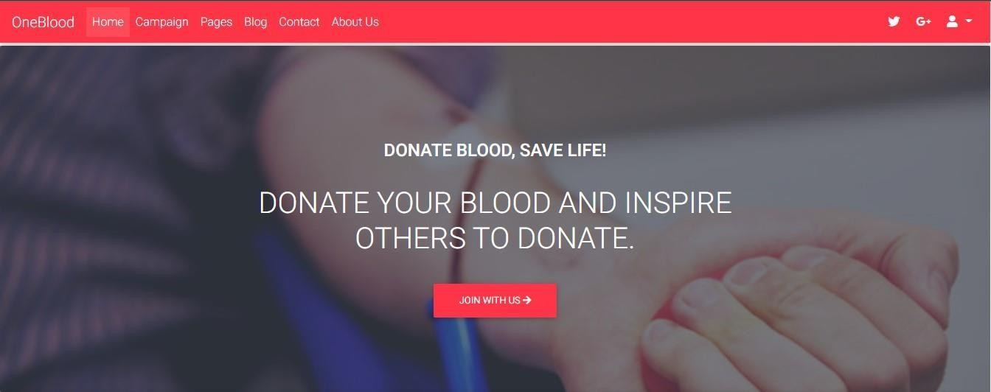

### Use of Favicon:

**Navbar:**

**Home Page- First section:-**

**Home Page Full Screen:**

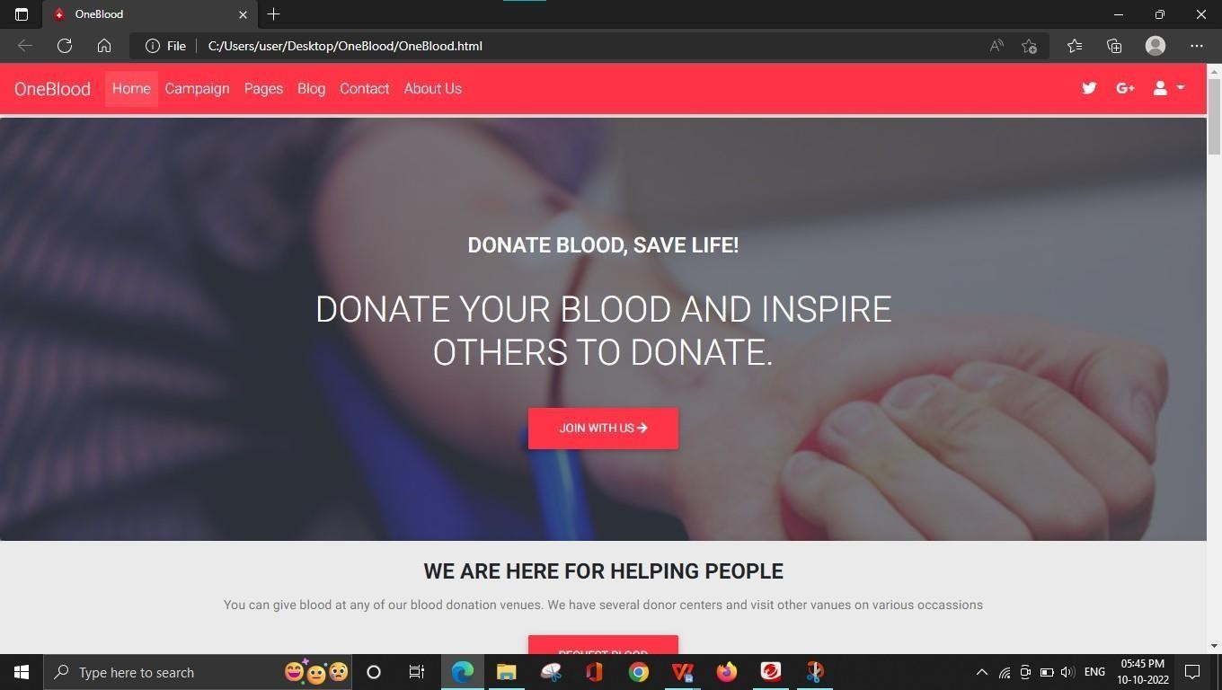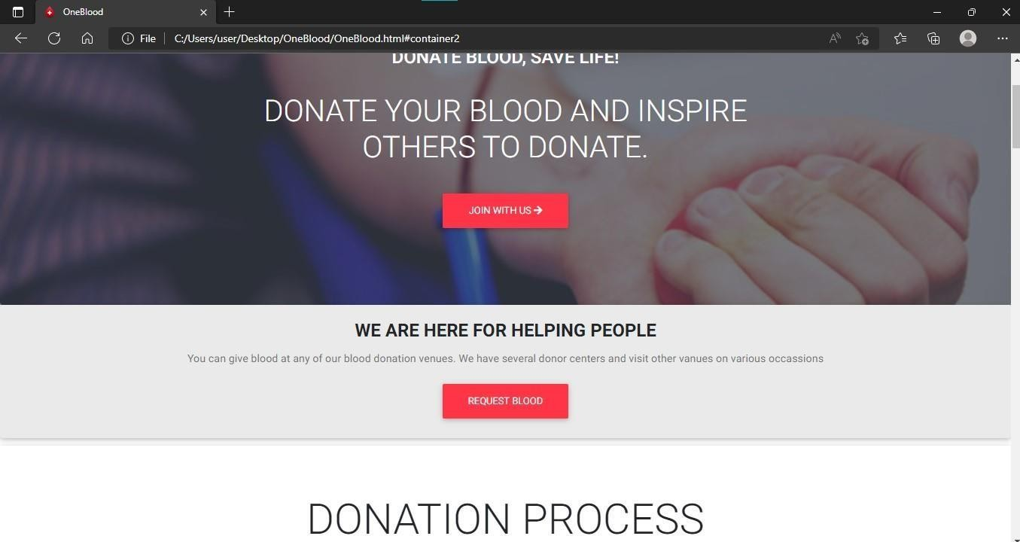

**Home page- next section:**

**Home page/Campaign**:

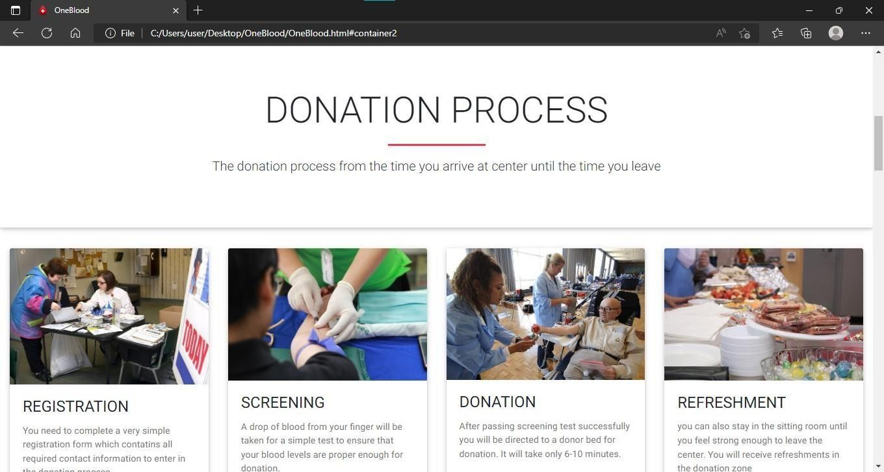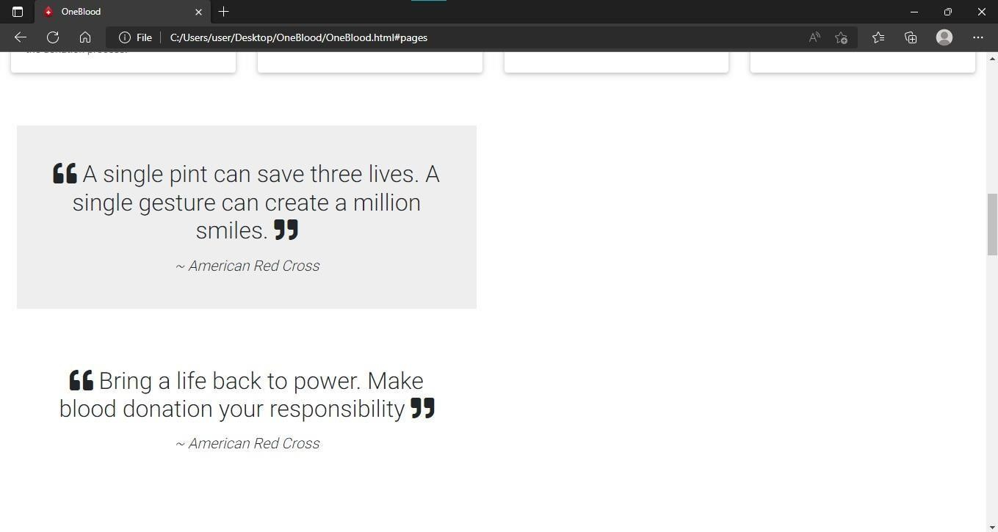

**Homepage/Pages:**

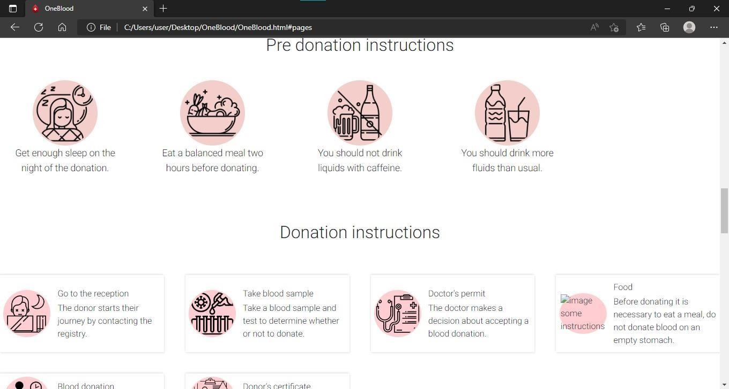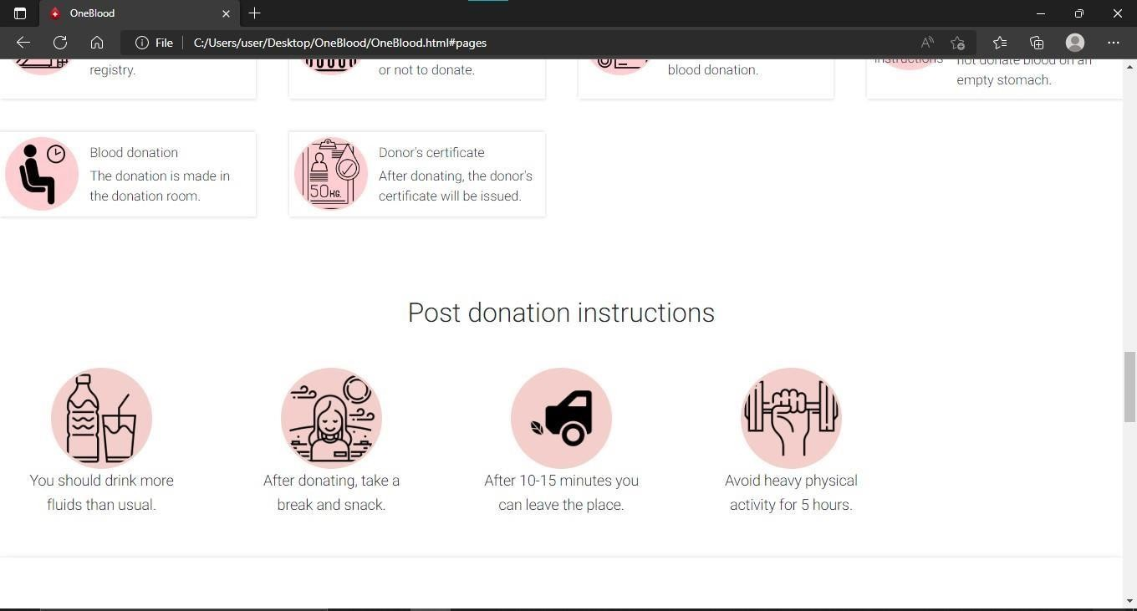

**Homepage/Blog:**

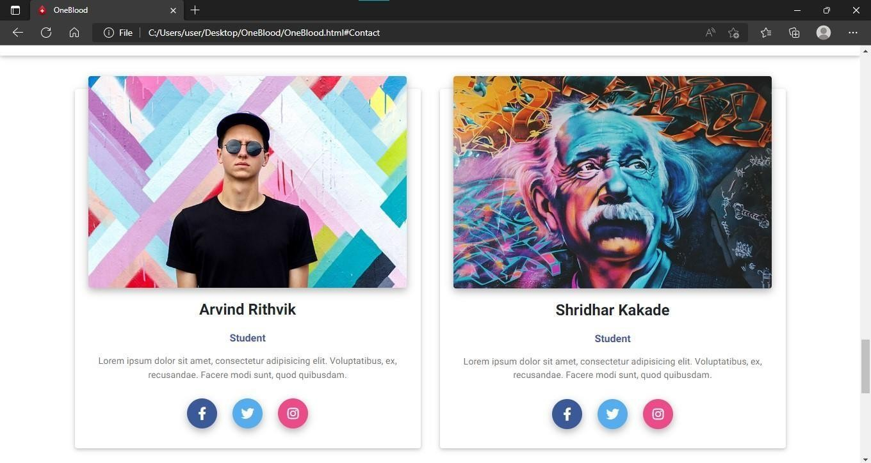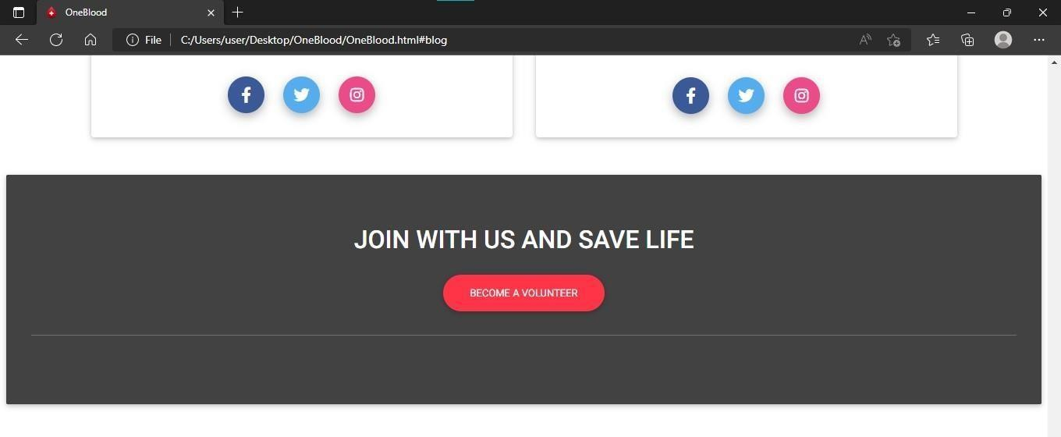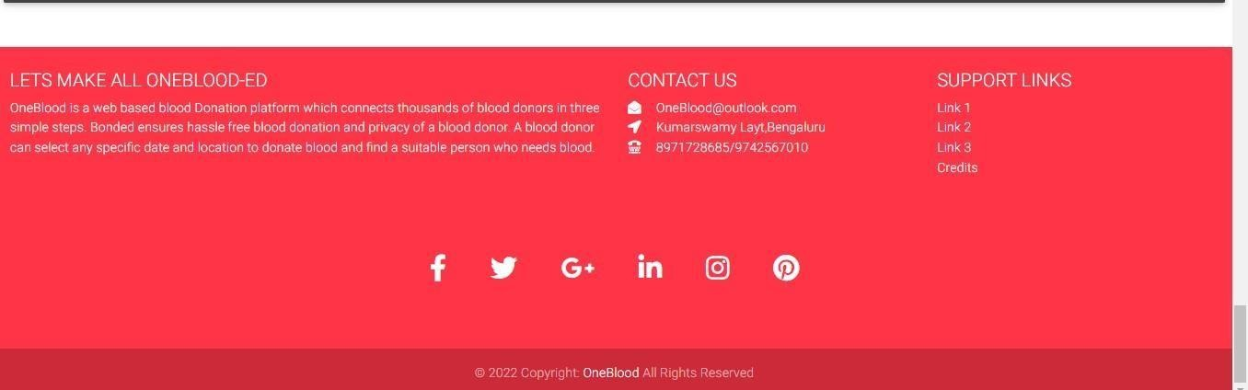

**Homepage/Contact us & About us:**

**Blood Request Form:**

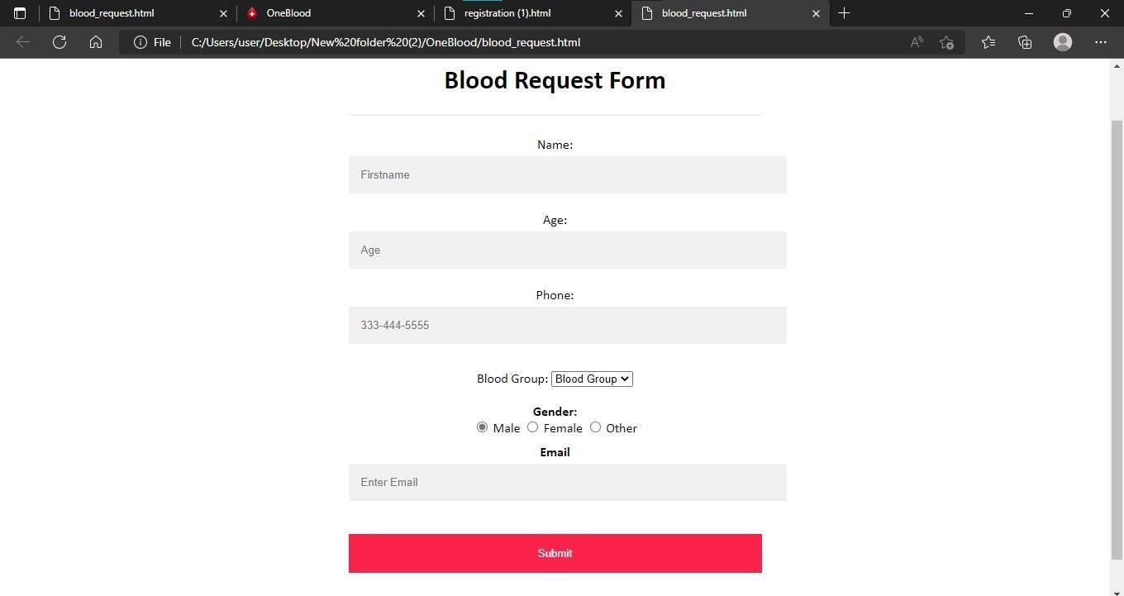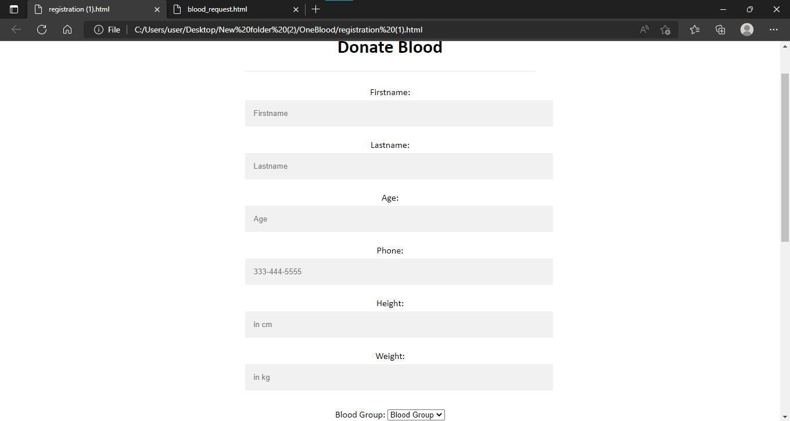

**Blood Donate Form:**

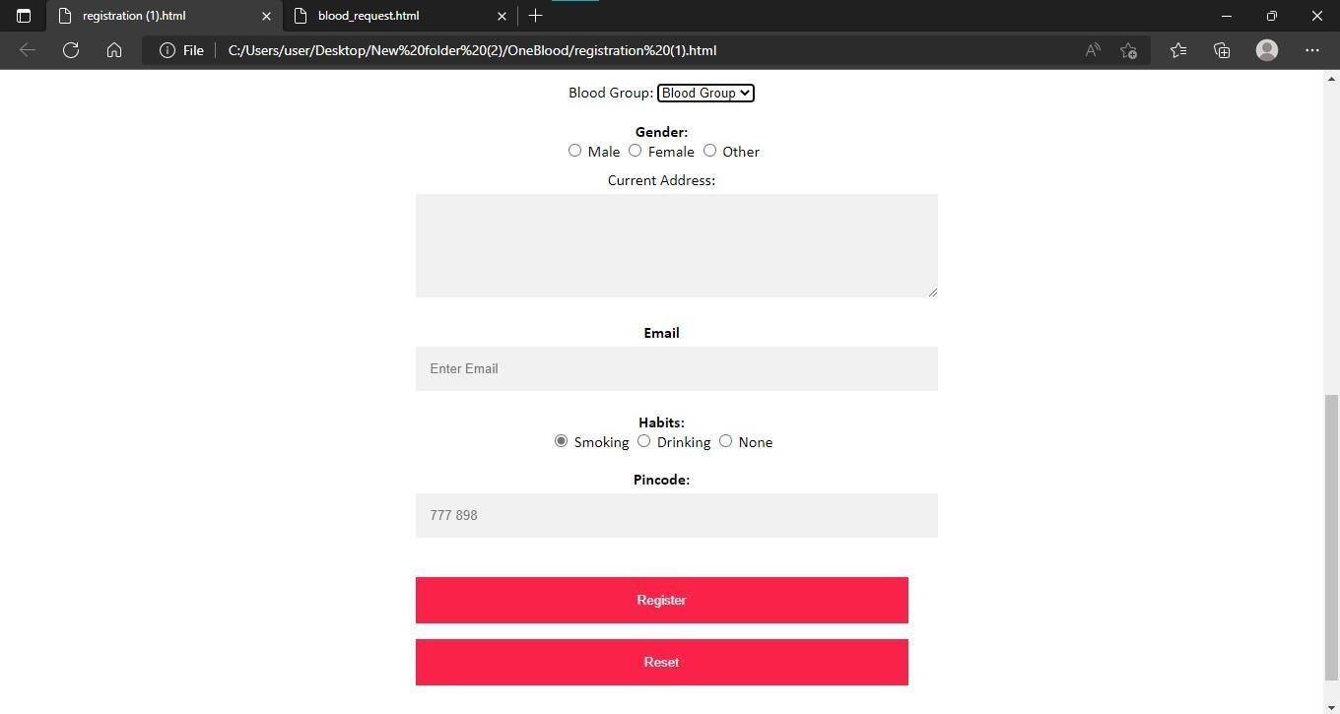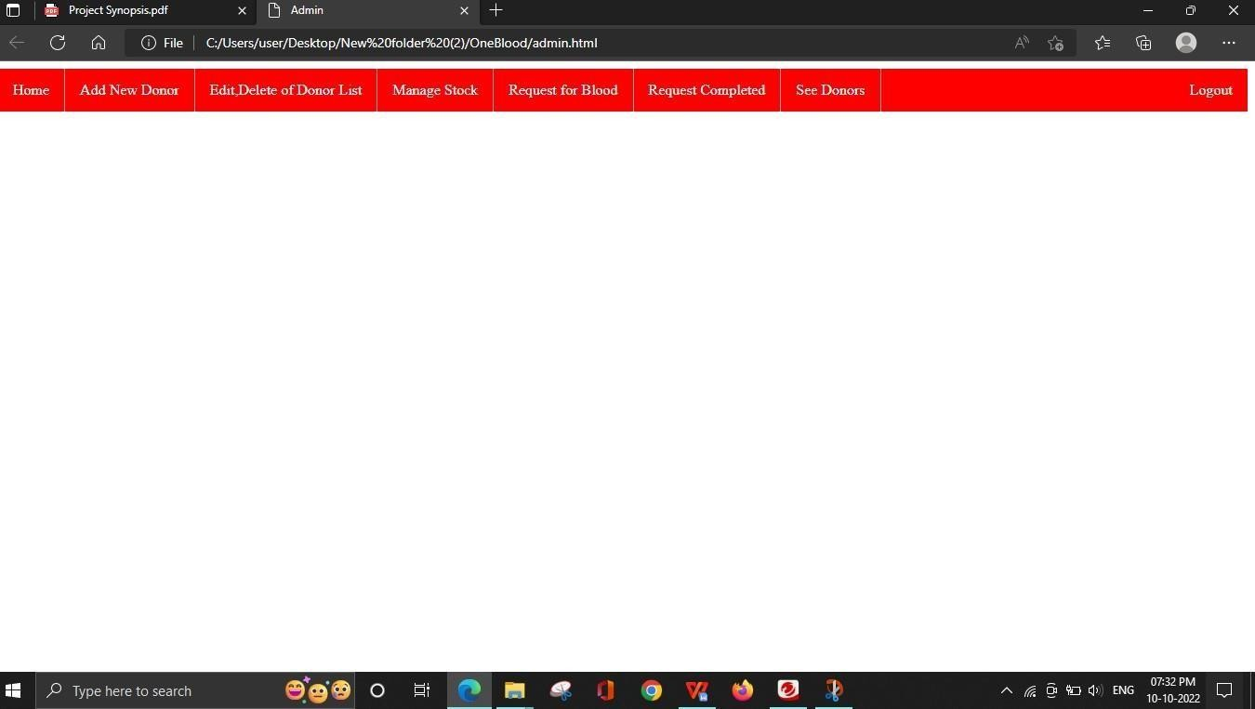

**Admin page:**

**Tools and Technologies**

**Requirements:**

#### Hardware Requirements:

* + - * Processor: intel Pentium Dual Core
      * RAM: 2GB or more
      * Hard Disk: 164GB or more
    1. Software Requirements:
       - Front End – Notepad/NetBeans IDE,]
       - Browser: Google Chrome
       - Operating System: Windows 7 or more
    2. Languages: HTML, CSS, JavaScript, Bootstrap

**Limitation of the project:**

This research study does not cover the actual blood collection activity, and actual blood transfusion operation. Blood donors and patients or recipients of blood donation are not system users, their registration or information will be encoded by the blood bank receptionists. Also, the study excludes the consideration of system security measures such as password expiration, use of CAPTCHA, idle window timeout, web caching, etc., audit trail, and back-up and recovery. It also includes Risk of large set of users & Data processing slow due to large set of users accessing.

**Future scope and more project reinforcement:**

One important future scope is availability of location-based blood bank details and extraction of location-based donor’s detail, which is very helpful to the acceptant people. All the time the network facilities cannot be use. This time donor request does not reach in proper time, this can be avoided through adding some message sending procedure this will help to find proper blood donor in time. This will provide availability of blood in time. The present Blood Bank project may be further developed for more complex transactions and to meet the requirements of modern-day dynamic System Operation New options and their respective implementation may be done for this purpose.

**Bibliograph**y

1. <https://www.w3schools.com/>
2. <https://www.geeksforgeeks.org/>
3. <https://getbootstrap.com/>
4. https://javatpoint.com/
5. https://guru99.com/